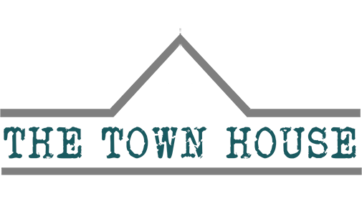

Privacy Policy

​
Last updated: March 1, 2020

OUR PRIVACY STATEMENT
​
SECTION 1 - WHAT DO WE DO WITH YOUR INFORMATION?

When you browse our website, we also automatically receive your computer’s internet protocol (IP) address in order to provide us with information that helps us learn about your browser and operating system.

Email marketing:

Only with your permission first, we may send you emails about new products and other updates. There are clear opt out instructions on those emails if you no longer wish to receive them.
SECTION 2 – CONSENT

How do you get my consent?

When you provide us with personal information to complete a form submission, or sign up for our newsletter, we imply that you consent to our collecting it and using it for that specific reason only.

If we ask for contact information from you (which will only be for our own marketing purposes, and will not shared with any third parties), we will either ask you directly for your expressed consent, or provide you with an opportunity to say no.
How do I withdraw my consent?

If after you opt-in, you change your mind, you may withdraw your consent for us to contact you, for the continued collection, use or disclosure of your information, at anytime, by contacting us at info@thetownhousemd.com or mailing us at: The Town House, 36 Cheshire St, Market Drayton TF9 1PF, United Kingdom.

SECTION 3 – DISCLOSURE

We may disclose your personal information if we are required by law to do so or if you violate our Terms and Conditions.
SECTION 4 – WIX

Your data is stored through Wix's data storage, databases and the general Wix application. They store your data on a secure server behind a firewall.
SECTION 5 - THIRD-PARTY SERVICES

In general, the third-party providers used by us will only collect, use and disclose your information to the extent necessary to allow them to perform the services they provide to us.
LINKS

When you click on links on our website they may direct you away from our site. We are not responsible for the privacy practices of other sites and encourage you to read their privacy statements.
SECTION 6 – SECURITY

To protect your personal information, we take reasonable precautions and follow industry best practices to make sure it is not inappropriately lost, misused, accessed, disclosed, altered or destroyed.
COOKIES

Our site uses cookies, and you will be asked upon entry to the website if you are happy to accept this by continuing to use the site.
SECTION 7 - AGE OF CONSENT

By using this site, you represent that you are at least the age of majority in your province of residence, or that you are the age of majority in your province of residence and you have given us your consent to allow any of your minor dependents to use this site.
SECTION 8 - CHANGES TO THIS PRIVACY POLICY

We reserve the right to modify this privacy policy at any time, so please review it frequently. Changes and clarifications will take effect immediately upon their posting on the website. If we make material changes to this policy, we will notify you here that it has been updated, so that you are aware of what information we collect, how we use it, and under what circumstances, if any, we use and/or disclose it.
QUESTIONS AND CONTACT INFORMATION

If you would like to:

Access, correct, amend or delete any personal information we have about you, register a complaint, or simply, want more information contact our Privacy Compliance Officer in post at: info@thetownhousemd.com

